Teacher Notes for “Characteristics of Life”

Biology is the scientific study of living things. The Student Handout, together with two videos, help students to understand the characteristics of living things and the challenges of distinguishing between living and non-living things. This analysis and discussion activity also introduces several themes that will be revisited in a general biology course.

Learning Goals
Living things share a variety of characteristics, including that they:
- acquire and use energy
- grow and develop
- reproduce
- respond to their environment
- maintain homeostasis
- have undergone evolutionary adaptation
- are made up of one or more cells
- share a universal genetic code (DNA).

Some non-living things share one or more of these characteristics, but a non-living thing does not have the majority of the characteristics of life. Some living things lack one or more of these characteristics (e.g. the ability to reproduce). Viruses are intermediate between living and non-living things since they have several characteristics of life, but lack many others.

Instructional Suggestions and Biology Background
If your students are learning online, we recommend that they use the Google Doc version of the Student Handout available at https://serendipstudio.org/exchange/bioactivities/lifecharacteristics. If you are using the Word version of the Student Handout to make revisions, please check the PDF version to make sure that all figures and formatting are displayed properly in the Word version on your computer.

A key is available upon request to Ingrid Waldron (iwaldron@upenn.edu). The following paragraphs provide additional instructional suggestions and background information – some for inclusion in your class discussions and some to provide you with relevant background that may be useful for your understanding and/or for responding to student questions.

During the class discussion of student answers to question 1, you may want to clarify that this activity is concerned with distinguishing between living things and non-living things and is not concerned with how you tell whether someone is dead or alive. Also, this activity is concerned with identifying shared characteristics of the whole range of biological organisms, including bacteria, other microorganisms, mushrooms, plants, and animals.

The two “Characteristics of Life” videos recommended on page 1 of the Student Handout are:
- ~2 minutes by Ricochet Science at https://www.youtube.com/watch?v=0NnFhY_STFQ
- ~8 minutes by Amoeba Sisters at https://www.youtube.com/watch?v=cQPVXrV0GNA
We recommend that, after a class discussion of the first video, you have students answer question 2, before you show the second video. The second video introduces students to the challenges of distinguishing between living things and non-living things. Some living organisms do not have every characteristic (e.g. reproduction). Some non-living things have one or more characteristics of life. Viruses have a few of the characteristics of living things and they interact intimately with the cells of living things, so viruses are included in the study of biology. However, many biologists would not characterize them as living.

You will probably want to supplement the discussion of natural selection in the Amoeba Sisters video by mentioning camouflage as an example of an evolutionary adaptation. In the section on homeostasis, this video mentions contractile vacuoles. The figure below can be used to help your students understand what contractile vacuoles are and how they function to pump out excess water that enters the cell by osmosis.

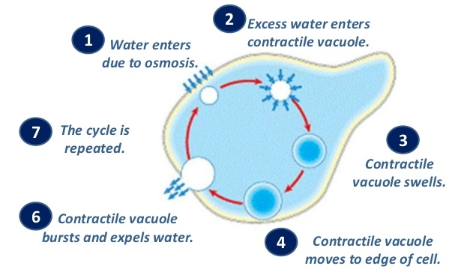
(https://image.slidesharecdn.com/osmosisdiffusionactivetransport-120831003333-phpapp01/95/osmosis-diffusion-active-transport-44-728.jpg?cb=1346373344)

If your textbook gives a different list of characteristics of life than these videos provide, you may want to have your students explicitly compare the two lists and identify and analyze similarities and differences.

Question 4 reinforces student understanding that some non-living things have one or two of the characteristics of living things, but the whole constellation of characteristics is required to identify something as living. This concept is illustrated in both of the introductory videos.

The following paragraphs provide more information about the specific examples in the figures in question 5, as well as some related general themes.

Frogs provide a familiar example of sexual reproduction and growth and development. Students may ask questions about additional aspects of frog biology. General information is available at https://www.burkemuseum.org/collections-and-research/biology/herpetology/all-about-amphibians/all-about-frogs, https://www.livescience.com/50692-frog-facts.html, and https://animals.howstuffworks.com/amphibians/frog.htm. An example of an evolutionary adaptation is the position of frog’s eyes, wide-set on the top of their heads. This gives frogs a wide field of view, which helps to compensate for their inability to turn their heads to scan
different parts of their environment. Gas exchange occurs primarily across the thin, moist skin. However, toads are a type of frog that generally are more adapted to land and have dry skin, so they often get oxygen through their mouth or lungs. | 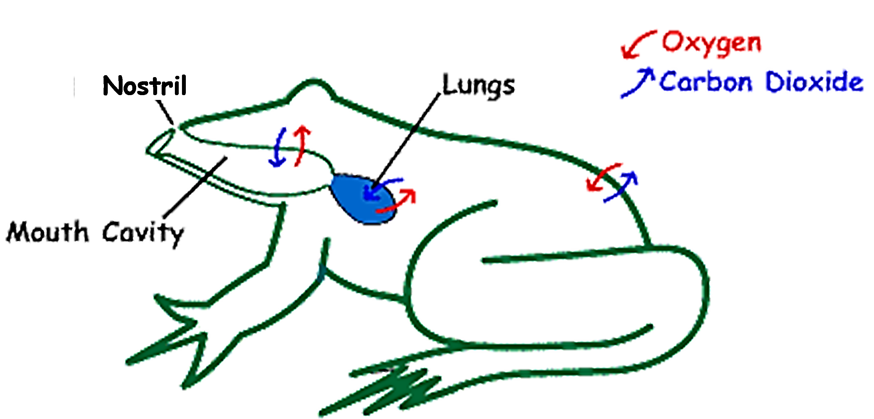  (https://www.brown.edu/Departments/Engineering/Courses/En123/MuscleExp/Frog%20Respiration.htm)

If you want to introduce an example of asexual reproduction, in a multicellular organism you can use this figure.  A hydra can reproduce by budding. The bud is formed of cells made by many repetitions of mitosis. Then the bud breaks off to form a daughter hydra. | 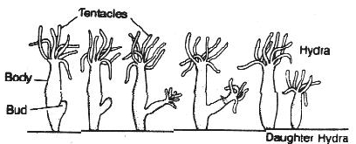  A hydra is an animal that lives in the water and uses its  tentacles to catch food.

Key concepts and learning activities to introduce students to mitosis, meiosis, fertilization and genetics are summarized in https://serendipstudio.org/exchange/bioactivities/MitosisMeiosis and https://serendipstudio.org/exchange/bioactivities/GeneticsConcepts.

When people think about plants acquiring and using energy, they often think only about photosynthesis. However, plants also need cellular respiration to produce ATP and hydrolysis of ATP to provide the energy for plants’ biological processes.  Photosynthesis makes glucose molecules which are used for cellular respiration or to produce the organic molecules needed for plant growth. In addition, some of the glucose is stored in starch molecules. In the dark, starch is broken down to glucose, which is used for cellular respiration to produce the ATP that provides the energy for the multiple biological processes that occur, even in the dark. | 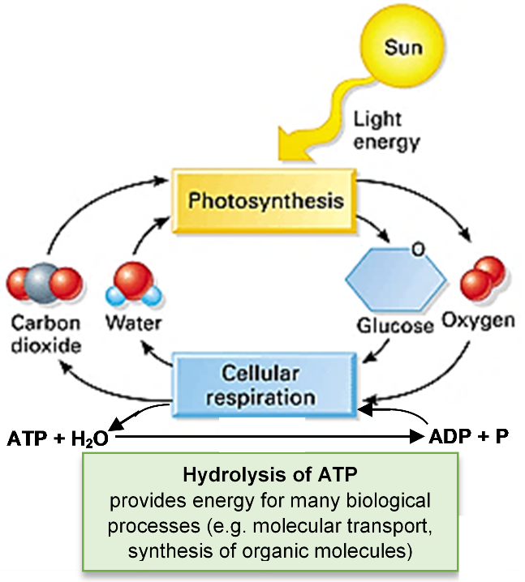

Learning activities to help students understand photosynthesis and cellular respiration are available at https://serendipstudio.org/exchange/bioactivities#energy.

The plant shown in question 5 has flowers (see figure below) and fruit (tomatoes), which are both parts of plants’ sexual reproduction. Fruits are eaten by animals which then excrete the seeds in other locations, together with feces which serve as fertilizer.

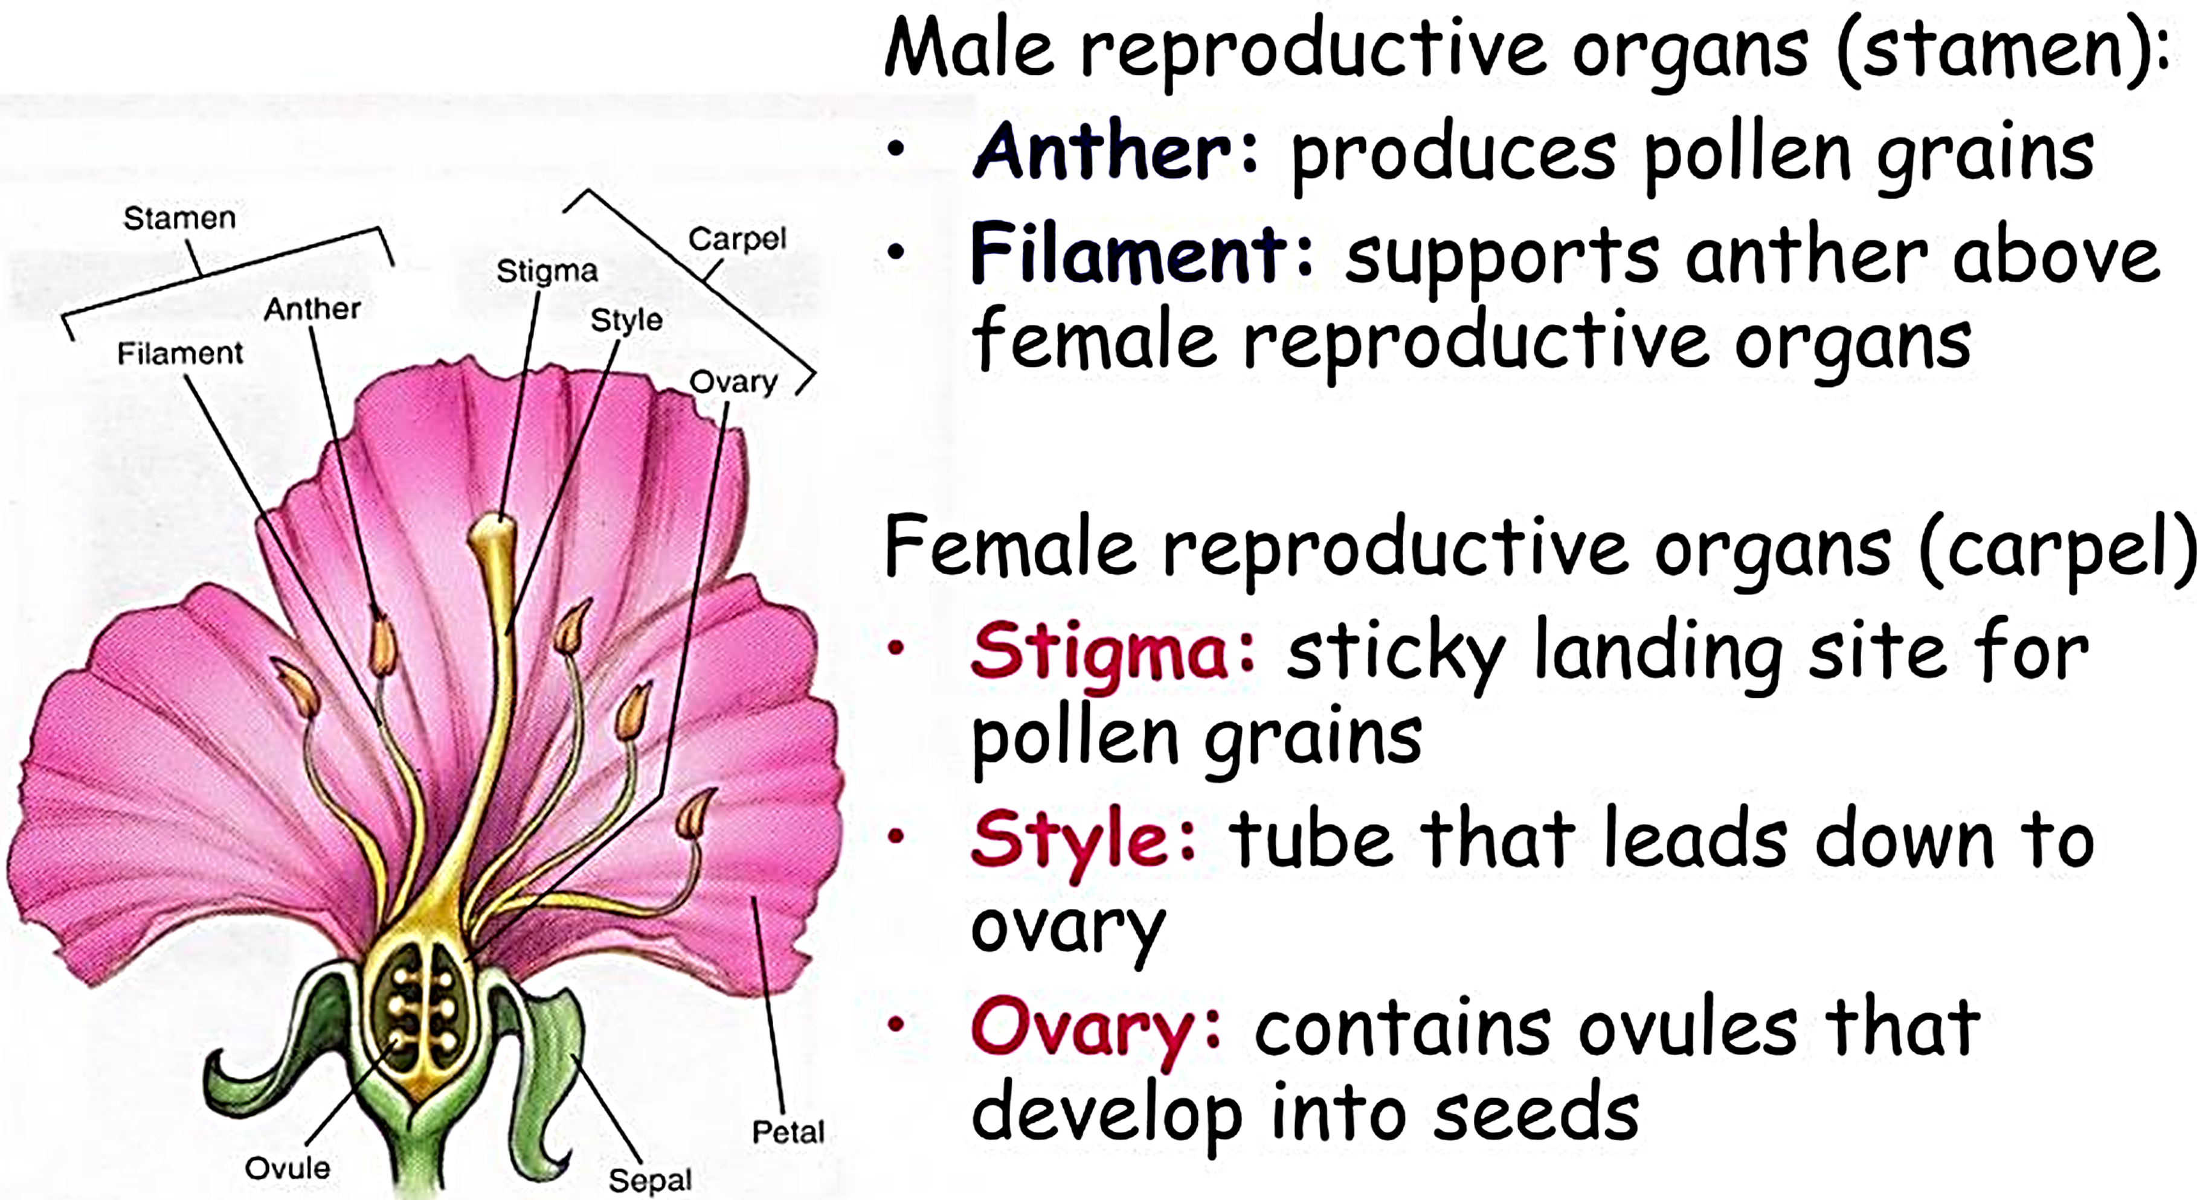
(https://image1.slideserve.com/2978507/reproductive-parts-l.jpg)

Temperature regulation is an example of homeostasis that involves behavioral responses (e.g. warmer clothes vs. fanning yourself) and physiological negative feedback (see figure below). For a learning activity about homeostasis, see https://serendipstudio.org/exchange/bioactivities/homeostasis.

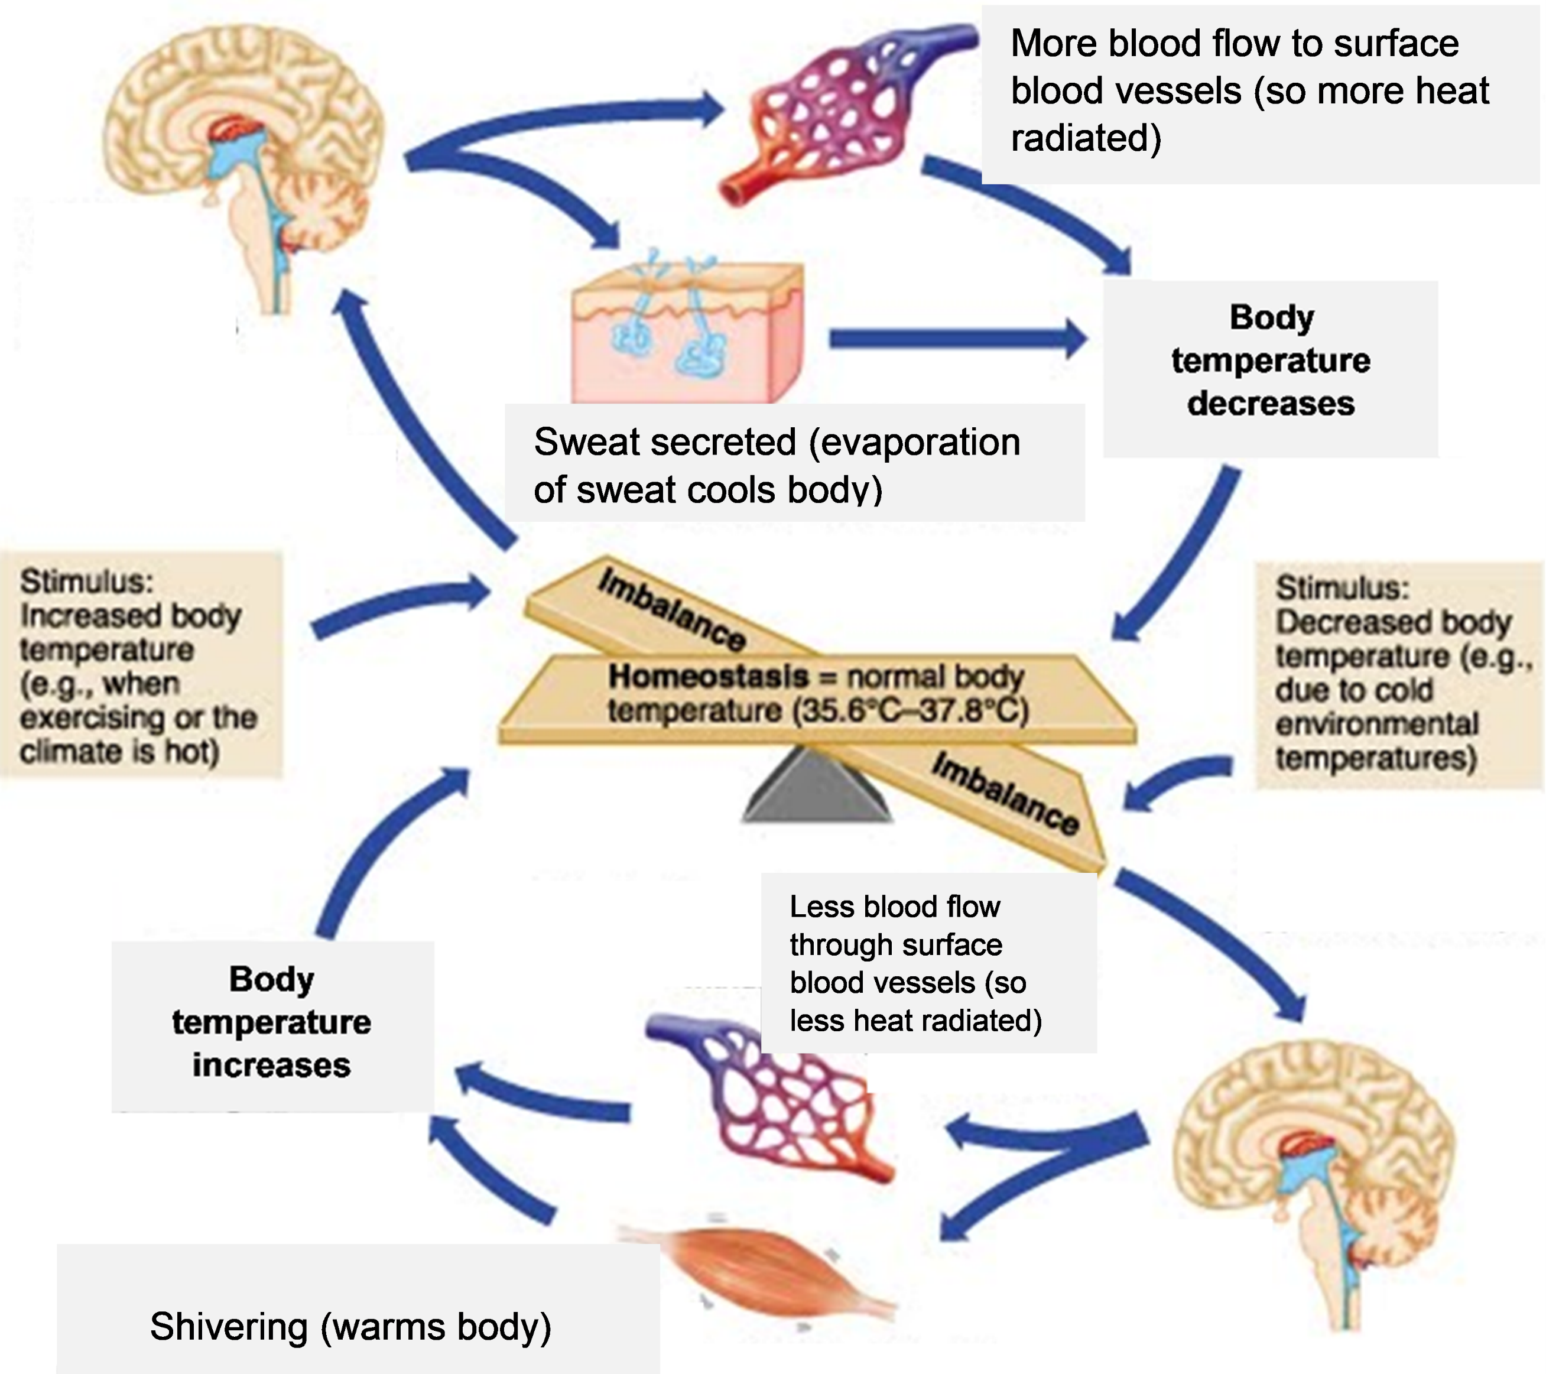
(Adapted from https://d2jmvrsizmvf4x.cloudfront.net/42IFA2i2ShiS1MpwS2yL_thermoregulation-campbell.jpg)

The hummingbird in the picture in the Student Handout is responding to the red color of the flower. The long narrow shape of the hummingbird’s beak and tongue are evolutionary adaptations for feeding on the nectar in tubular flowers. Evolutionary adaptations of the flower include the red color (which attracts hummingbirds), the tubular shape (which holds lots of nectar), and reproductive organs that extend far enough to contact the hummingbird’s head (so flowers get cross pollinated) (https://news.ku.edu/2016/06/09/study-flowers-co-evolution-bees-and-hummingbirds-earns-hileman-major-grants). An interesting 1-minute video shows how the hummingbird’s tongue takes up nectar from an artificial tubular flower (https://www.youtube.com/watch?v=QYoYQAbPXbU).

For learning activities that introduce students to natural selection and other aspects of evolution, see https://serendipstudio.org/exchange/category/serendip-topic-tags/evolution.

The last figure in question 5 shows the cells in human skin. Your students should understand that all living things are made up of one or more cells. This figure shows some of the similarities and differences between prokaryotic and eukaryotic cells. The defining difference is that eukaryotic cells have a membrane-enclosed nucleus, and prokaryotic cells do not. Eukaryotic cells have other membrane-enclosed organelles. The diameter of a eukaryotic cell is roughly 10 times the diameter of a prokaryotic cell (which is roughly as large as the mitochondria shown in the eukaryotic cell).  As you know, there are many different types of eukaryotic cells. Plant cells have the components shown in the generic animal cell in this figure, plus chloroplasts, a cell wall, and a large vacuole.  For learning activities about cell structure and function, see | 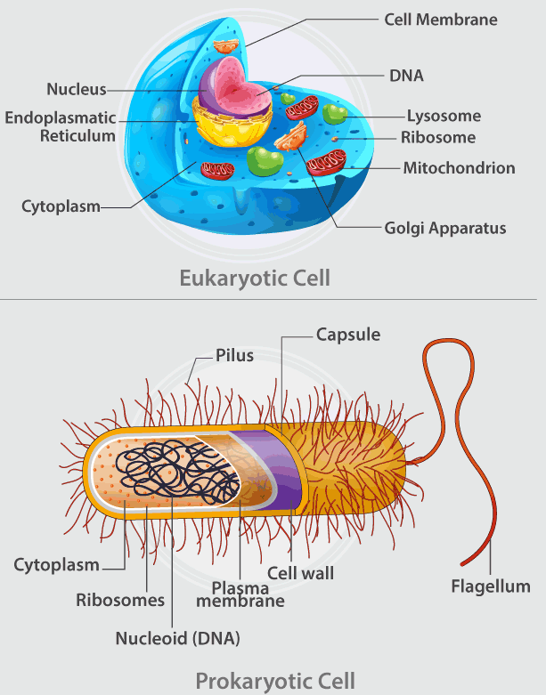  (https://cdn1.byjus.com/wp-content/uploads/2017/08/Prokaryotic-Cell-And-Eukaryotic-Cell.png)
https://serendipstudio.org/exchange/bioactivities#cells.

After question 5, students are introduced to a universal genetic code as another characteristic of life (at least life on earth). DNA is made up of four types of nucleotides, and a sequence of three nucleotides codes for each of the 20 different types of amino acids commonly found in proteins. This DNA code plays a crucial role in allowing each type of organism to produce the many different types of proteins found in each organism. The DNA code is the same in all organisms, with rare, minor exceptions (https://www.khanacademy.org/science/high-school-biology/hs-molecular-genetics/hs-rna-and-protein-synthesis/a/the-genetic-code). The universality of this genetic code provides evidence that all organisms are evolutionarily descended from an ancestral organism which already had this genetic code. The astonishing variety of organisms, from tiny bacteria to gigantic whales, have all been produced by evolutionary “descent with modification”. For learning activities about DNA and proteins, see https://serendipstudio.org/exchange/bioactivities/proteins and https://serendipstudio.org/exchange/bioactivities#molecbio.

A mule is the offspring of a female horse and a male donkey. A horse has 64 chromosomes in each cell and a donkey has 62 chromosomes, so a mule has 32 horse chromosomes and 31 donkey chromosomes in each cell. Meiosis is needed to form eggs and sperm, and homologous chromosomes need to pair during meiosis. The horse and donkey chromosomes are sufficiently different that they don’t reliably pair during meiosis in a mule. Furthermore, since mule’s cells have an odd number of chromosomes, it is impossible for each chromosome to pair with a homologous chromosome during meiosis. Failed meiosis is the reason why mules cannot reproduce (with very rare exceptions). For more information, see https://en.wikipedia.org/wiki/Mule and https://genetics.thetech.org/ask/ask225.

Question 6 revisits the concept that viruses have some, but not all, of the characteristics of life. (This concept was introduced at the end of the Amoeba Sisters video.) Viruses reproduce, but only by commandeering the molecular machinery of cells in living organisms. The figure below shows how infected cells replicate the coronavirus that is causing the pandemic of 2019-2020. All viruses have genetic information. Some have DNA; others, including the coronaviruses, have RNA as the genetic material. Evolutionary change in viruses can result in the emergence of new threats to human health (see the video at https://www.youtube.com/watch?v=NJLXdsO1GBI). However, viruses lacked other characteristics of life. For example, viruses are not made up of one or more cells, and they do not acquire and use energy or maintain homeostasis. Viruses demonstrate that the distinction between living and non-living things is not clear-cut.

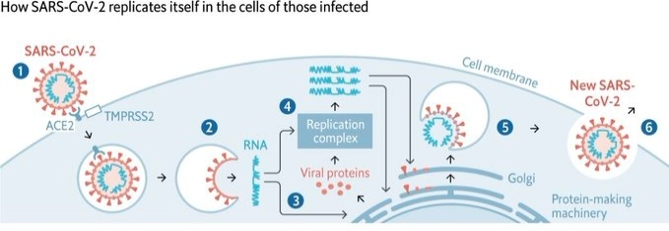
(https://1.bp.blogspot.com/-7xw8g5d7nD4/Xm6HkKbzv-I/AAAAAAAABN0/CjKcdFWirDAAMK4LddGomEY7J98COcXYACLcBGAsYHQ/s1600/cell2.jpg)

Sources for Figures in Student Handout
- Frogs – https://media.istockphoto.com/vectors/coloring-page-with-life-cycle-of-frog-sequence-of-stages-of-of-frog-vector-id1028224944
- Plant in sunlight – https://photosynthesiseducation.com/wp-content/uploads/2017/05/Photosynthesis-for-Kids-Infographic.jpg
- Sweating and shivering – https://image.freepik.com/free-vector/kids-heat_6460-433.jpg and https://lenaweegreatstart.org/blog/wp-content/uploads/2014/01/clipart_snow_cold.jpg
- Hummingbird – https://primaryevolution.files.wordpress.com/2015/02/purple-throated_carib_hummingbird_feeding.jpg
- Skin cells –https://images.topperlearning.com/topper/question_uploads/CBSE_Bio11_AnimalTissue_SAQ_CLA_files/20140722151604_image002.jpg
- DNA – https://www.pngitem.com/pimgs/m/33-332753_basic-kintalk-ucsf-dna-gene-on-a-chromosome.png

By Dr. Ingrid Waldron, Department of Biology, University of Pennsylvania © 2022. These Teacher Notes and the related Student Handout are available at https://serendipstudio.org/exchange/bioactivities/lifecharacteristics.

